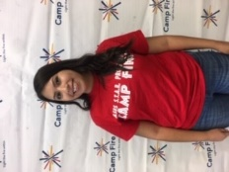

Executive director Sandra Rutherford

After school program director George Gutierrez

Brenda zarate

instructor

Linsey williams

instructor

Cristina Suarez

instructor

Paola chavez

Lead instructor

Alicia jimenez

Site supervisor

camp fire

**STAFF**

**cambridge elementary school**